Record No: 0663
JAMES AUBREY HENRY BELLINGHAM SOMERVILLE (“Jim”)
of Twissells, Frampton Mansell, Gloucestershire

Second son of Bellingham Arthur Somerville (0631) by his wife Margaret Hall Clinch (0632) daughter of William Clinch (0633) by his wife Rachel Hall Wright.

Birth: 23 Mar 1884 at 11, The Crescent, Queenstown, Co Cork
Bapt: 21 Sept 1884 at St Audoen’s Dublin
Marriage: 28 June 1927 at Southwell Minister, Nottinghamshire, to Lucy Margaret(0664), youngest dau of Sir Ralph Starkey of Norwood Park, Southwell.
Death: 13 Apr 1950, at Clermont, Rathnew, Co Wicklow. Bd 15 April 1950 at Rathnew
Cemetery, Co Wicklow

Notes: Lt Col. Royal Artillery

Entered RMA, Woolwich on 30 January 1901; at half yearly inspection by Earl Roberts on 23 December 1902, he was tenth on the list receiving 17,352 marks, and recommended for commission in the Royal Artillery.
His commission was signed on 17 February 1903 and his appointment was dated wef 24 December 1902.
He was appointed 2nd Lieut.in the Royal Garrison Artillery on 24 February 1903,attached temporarily to the RA at Falmouth, then appointed to 45th Company, then at Aden, but attached to the Depot at Fort Rowner, Gosport pending return of the Company from Aden. In November 1903, he was transferred to the 68th Company RGA at Mauritius, under orders for Roorkee, India. He sailed from Tilbury Docks in SS Omrah on20 November 1903, transshipped at Ceylon arriving Mauritius on 25 December 1903. He left Mauritius in February 1904, and landed Bombay for Roorkee.
Promoted Lieut on 16 January 1906 -- London Gazette
Capt on 30 October 1914 -- Army List
Major on 13 July 1917 -- Army List
Lt Col on 23 September 1931 – Army List

World War I:
Tochi Valley and Derajat 1914/15
Mesopotamia 1916 (28thMB)
Mahaud 1917
Egypt and Palestine(29thMB) 1918
Despatches LG 1914/15
S., BWM., VM., DSO..

Waziristan 1921-1924
Quetta 1935

World War II: Lt Col Royal Artillery (1939-1940)
Squadron Leader Royal Air Force Volunteer Reserve (1940-1943)
Lt Commander Royal Navy Volunteer Reserve (1944-1945)

d.s.p

Source: Somerville Index

Further research:
1891 Census: Witney, Oxfordshire
1901 Census: Gentleman cadet, Woolwich (17 years old)

D.S.O. gazetted 3 June 1919 "in connection with military operations in Egypt"

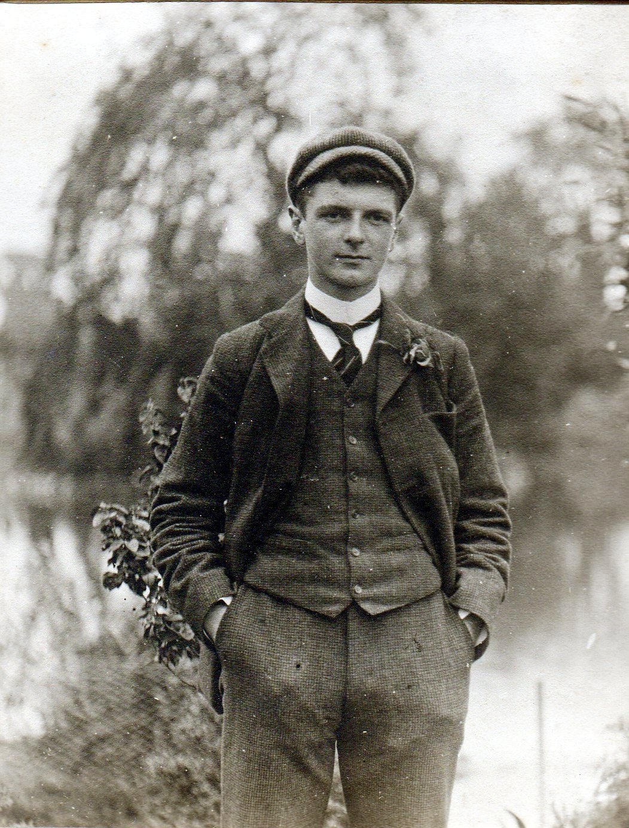

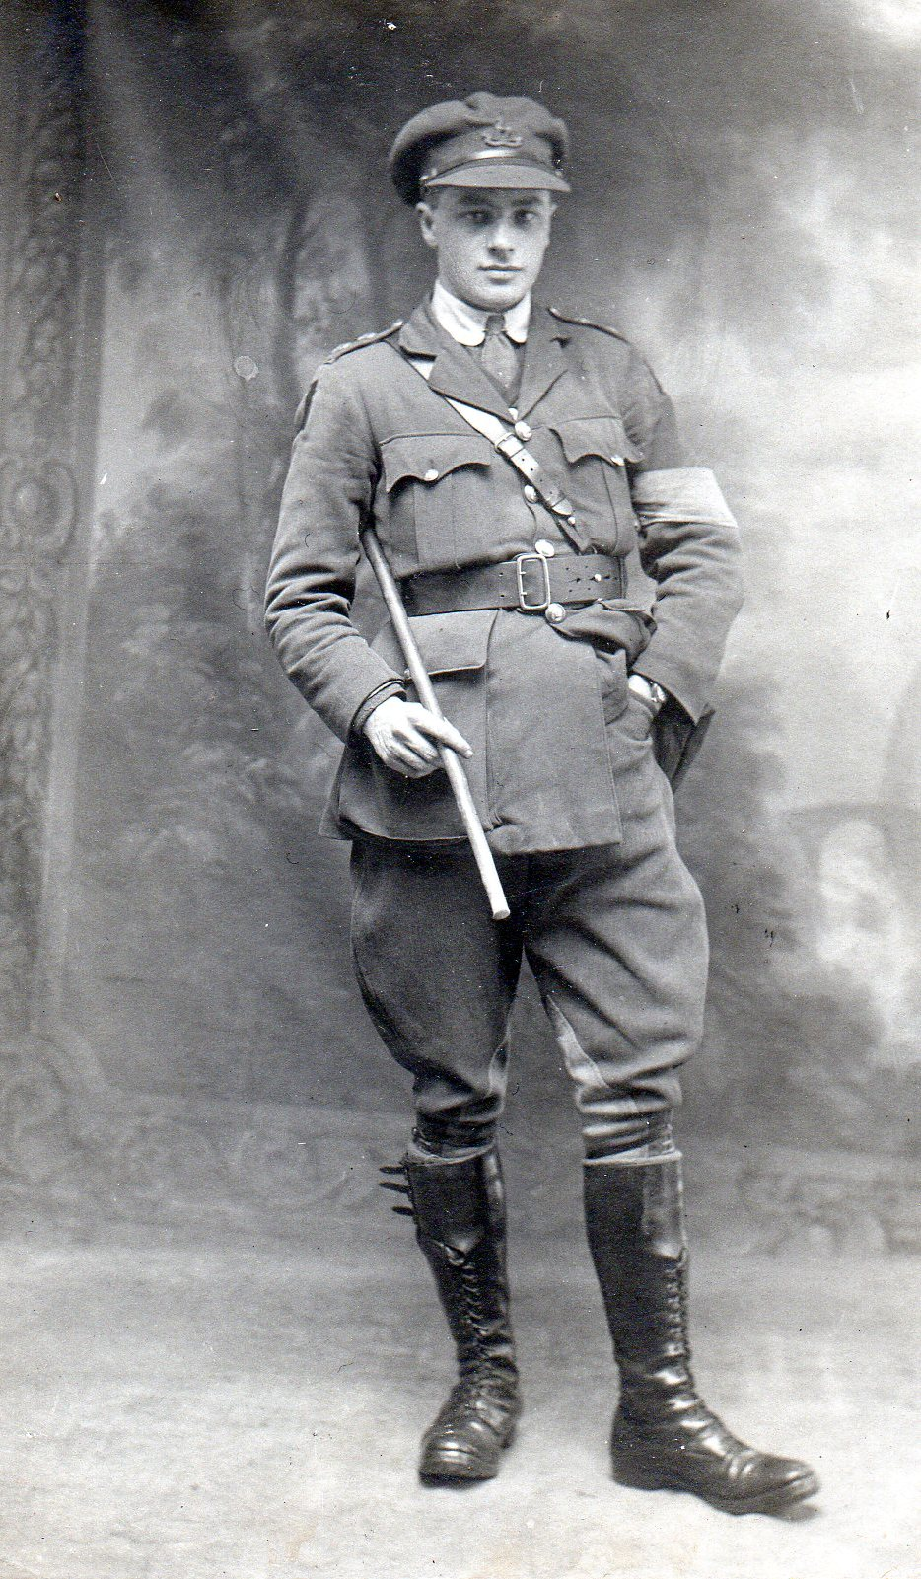

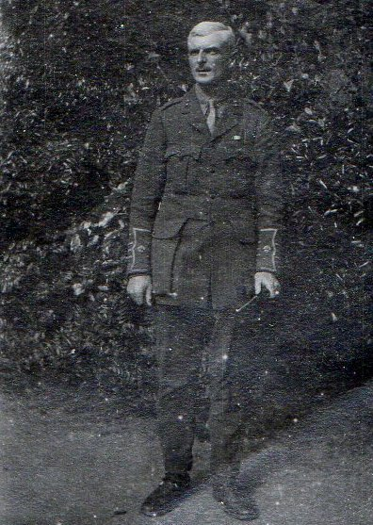

(NB The middle photo above is Regi, not Jim, taken in 1916 shortly after his father’s death.)

SOMERVILLE, Lt-Colonel James Aubrey Henry Bellingham
DSO 1919
Born 1884; 2nd s of late B. A. Somerville, RIC; m 1927, Margaret Lucy, y d of Sir J. R. Starkey, 1st Bt; died 13 April 1950

Education
RMA, Woolwich

Career
Served Royal Artillery, 1902–36; European War, 1914–19 (despatches, DSO) retired, 1936; RAFVR 1940–43; Squadron Leader RAFVR 1942; Lieut-Comdr RNVR 1944–45

Club
Army and Navy

Address
Twissells, Frampton Mansell, Glos
‘SOMERVILLE, Lt-Colonel James Aubrey Henry Bellingham’, Who Was Who, A & C Black, 1920–2008; online edn, Oxford University Press, Dec 2007 [http://www.ukwhoswho.com/view/article/oupww/whowaswho/U232008, accessed 18 July 2011]

Jim was especially fond of his cousin Lily(0659), daughter of Henry Bellingham Somerville(0628). WBRBS has a small silver locket , containing a miniature book of English, Irish and Scottish songs given by Jim to Lily on her 21st Birthday.

Jim was a keen sportsman in India. He collected many trophies, which decorated Clermont up to the end, when Greta offered them to the natural History Museum in Dublin where some of them hung for many years.

WBRBS from personal knowledge and conversation with Regi

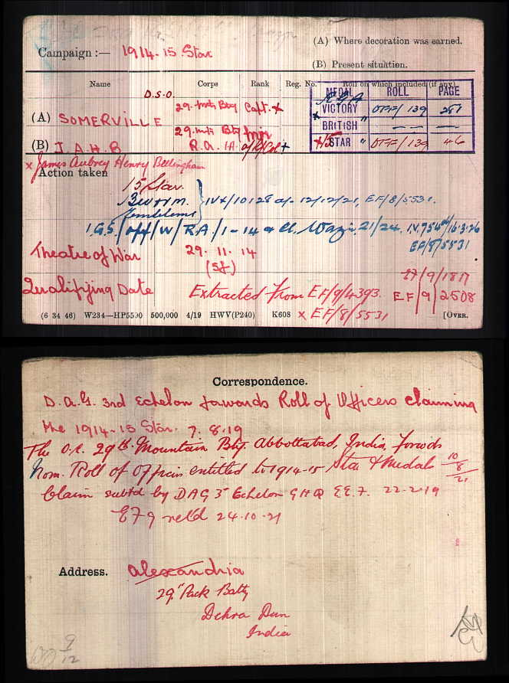
Transcript of Letter from Jim Somerville to his neice, Merlie Truell.
R. A. Mess,
Bulford Camp
Salisbury.

Telephone 89 Bulford.
August 19th 1925
My dear Merlie,
It was very nice to get your letter, or rather half letter, today. The only reason I did not write to you before was that I really had nothing to say. I could have said “I’m quite well, thank you” and “How are you”, but that would not have filled up a letter. It would not have interested you very much to know that I had had a very good breakfast today, thank you very much, and had also had a very nice lunch, and was looking forward to my tea and dinner later on – and as nothing very much goes on between there would not have been very much more to say. I could of course also say that the sun was shining, the rain was raining, the wind was winding, but as these are their usual occupations the news would hardly have been wildly exciting.
Now I can only tell you of my occupation for the last few days. On Sunday I went over to see some people in Surrey, and spent the afternoon eating plums and playing with two little girls aged 3½ and 1½ or thereabouts. On Monday afternoon I went to a place about 30 miles away and fished. I caught 4 small fish which I threw back and also hooked two large fish which went back of their own accord before they were landed. I had dinner there, played bridge after dinner and got back here at 1.30 in the morning. Yesterday afternoon I went to see Heather and Uncle Pat. I found Uncle Pat in bed with malaria. I came back here in pouring rain, and went to the cinema in the evening. Today I am busy writing this.
I am very glad to hear Julie had a bath last week, even although she did not expect it at the moment. I hope she got no ill after effects from it, as your Aunt Cecil seems to have got from a similar rash act. I hope she has by now fully recovered.
Do write me some more long letters and don’t mind very much if I don’t answer them at once. You see, I don’t have very much to write about, and I can’t always hope to make them as interesting and newsy as this one. You’ve got much more to write about.
Give my love to every one
Your “decrepit” uncle
Jim
Transcript of letter from Jim Somerville to Merlie Truell

Please give enclosed letter to Grannie
Royal Artillery Mess
Shoeburyness
19 – 8 – 26
My dear Merlie

Many thanks for your letter giving all the important Clermont news but you forgot to say whether Trick had passed a good night. You must feel very *happy/worried now that you have got your brother with you,
*erase whichever is inapplicable

it is always so * nice/a nuisance to have * dear/darling little children *playing/quarrelling around you –
*as before

Will you please thank your Daddy for his letter, and tell him, as he appears to be in doubt and wants to know, that I was (not) one of the queue at the Oval on Monday night. If I had been in London that night, on the contrary, I should have been one of the queue (the first probably) of those trying to get away by the first train from that village out of pure kindness of heart of course, in order to give others more room.

Geoffrey and I are both very happy now, thanks. We no longer scratch to each other all night; having lost the last of our little friends from Clermont. We hope they are happier too, as they are no longer being chased from pillar to post elbow to knee.

I intended to go to London yesterday to get a frock for the dance on Monday, but as I couldn’t get away, I had to get a deputy to get one for me. He got one, which is going to arrive on Saturday morning. He says it is a Pierrot Costume of emerald green and orange, with black knobs – It sounds nice and quiet, something inconspicuous, if it doesn’t resemble a Sinn Fein flag with smuts on it.

Please give my love to all at Clermont, starting from Granny,
and |
mummy |
down |
to |
little |
Georgie Porgie
Yourself
to
again
little
a
up Your wonderful Uncle
go
then James
and

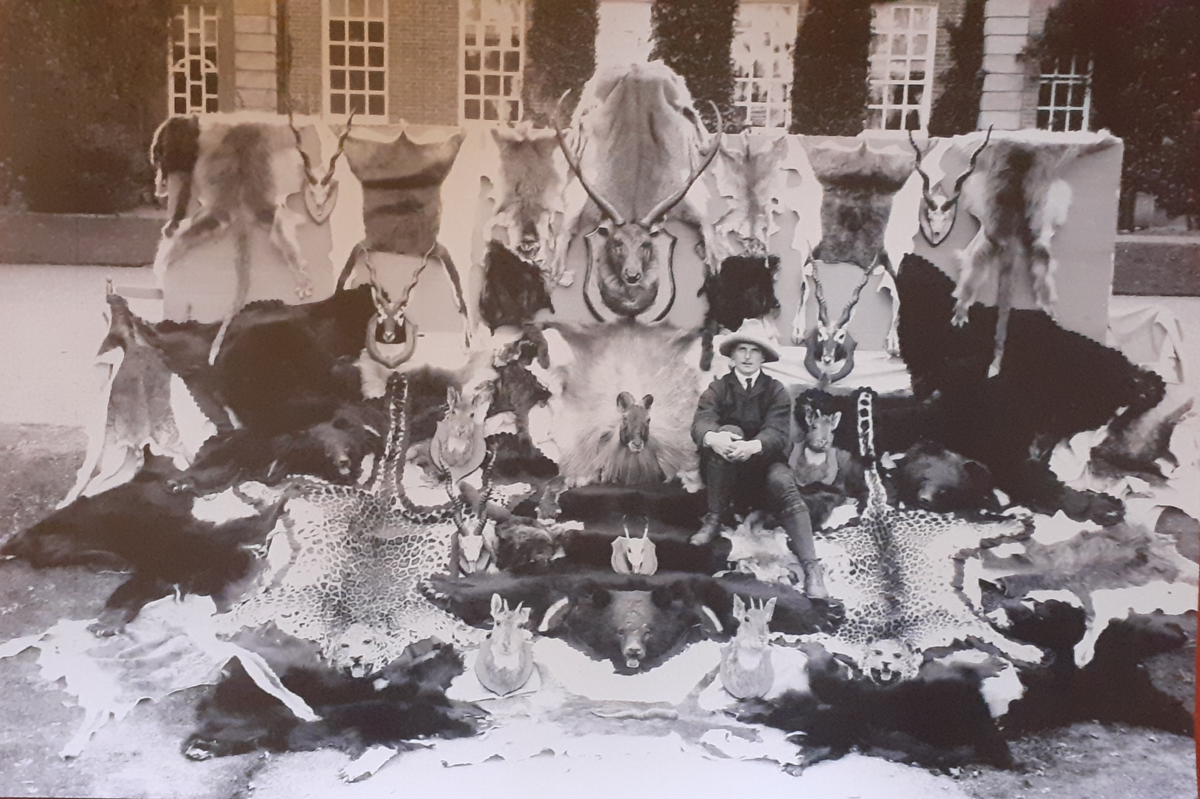
Jim and his ‘big game’ trophies at the back of Clermont

